2013-UA-01-1.odt Colourful Table

0 medium | I: easy | II: ---- | III: ---- | IV: ----

Answer Type: Multiple Choice (may be interactive)

Body

A little beaver would like to pave his new room with different coloured tiles:

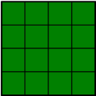
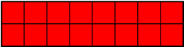
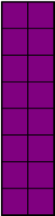
He decided that he will not rotate or cut the tiles in any way.

He wants to make his room as colorful as possible.

Question

What is the maximum number of different colors he can use to pave the room in the picture?
- It is impossible
- 1
- 2
- 3

Answer

d) 3

Explanation
With the given tiles you have to pave the room, that is 10 squares long and 8 squares wide. Your tiles are at most 8 squares long, so you need to use at least one with the length of 2. The rest od the room could be paved with either red tiles or green ones or both. As you want the room to be as colorful as possible, you use both.
For example:
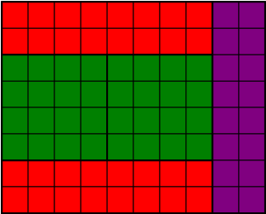

It's informatics

The partition on the subsets of given sizes is one of the classical problems in the Algorithms theory.
It is packing problem, where we have an area and we decide how to cover the area with certain shapes.

Keywords

Partition, graphical algorithm

Websites

Internal Use

Wording

Comments
Christian Datzko, Switzerland, christian.datzko@edubs.ch: see 2014-UA-01-review.ods.

Špela Cerar 2014-06-03: Changed wording, could be interactive, the vector graphics (svg) should be made

Peter Garscha, Austria, peter@rlsux.com, 2014-06-03: svg-graphics missing, it's informatics need more explanation.

Ahto Truu, ahto.truu@ut.ee (2014-09-25): regenerated all graphics in SVN and PNG.

Files

2013-UA-01-1.odt (this file)
floor8x10.png
floor8x10.svg
tile2x8red.png
tile2x8red.svg
tile4x4green.png
tile4x4green.svg
tile8x2purple.png
tile8x2purple.svg
floor8x10answer.png
floor8x10answer.svg

Authorship

author: Maria Hasanova, osvitarda@rambler.ru
translating: Lesia Ilishchuk, ilishchuk@i.ua
revision: Špela and Maciej

License

Copyright ©2013 Bebras - International Contest on Informatics and Computer Fluency.
This work is licensed under Creative Commons Attribution-NonCommercial-ShareAlike 3.0 Unported (CC BY-NC-SA 3.0).
Visit: http://creativecommons.org/licenses/by-nc-sa/3.0/

